Questione one
crosstab
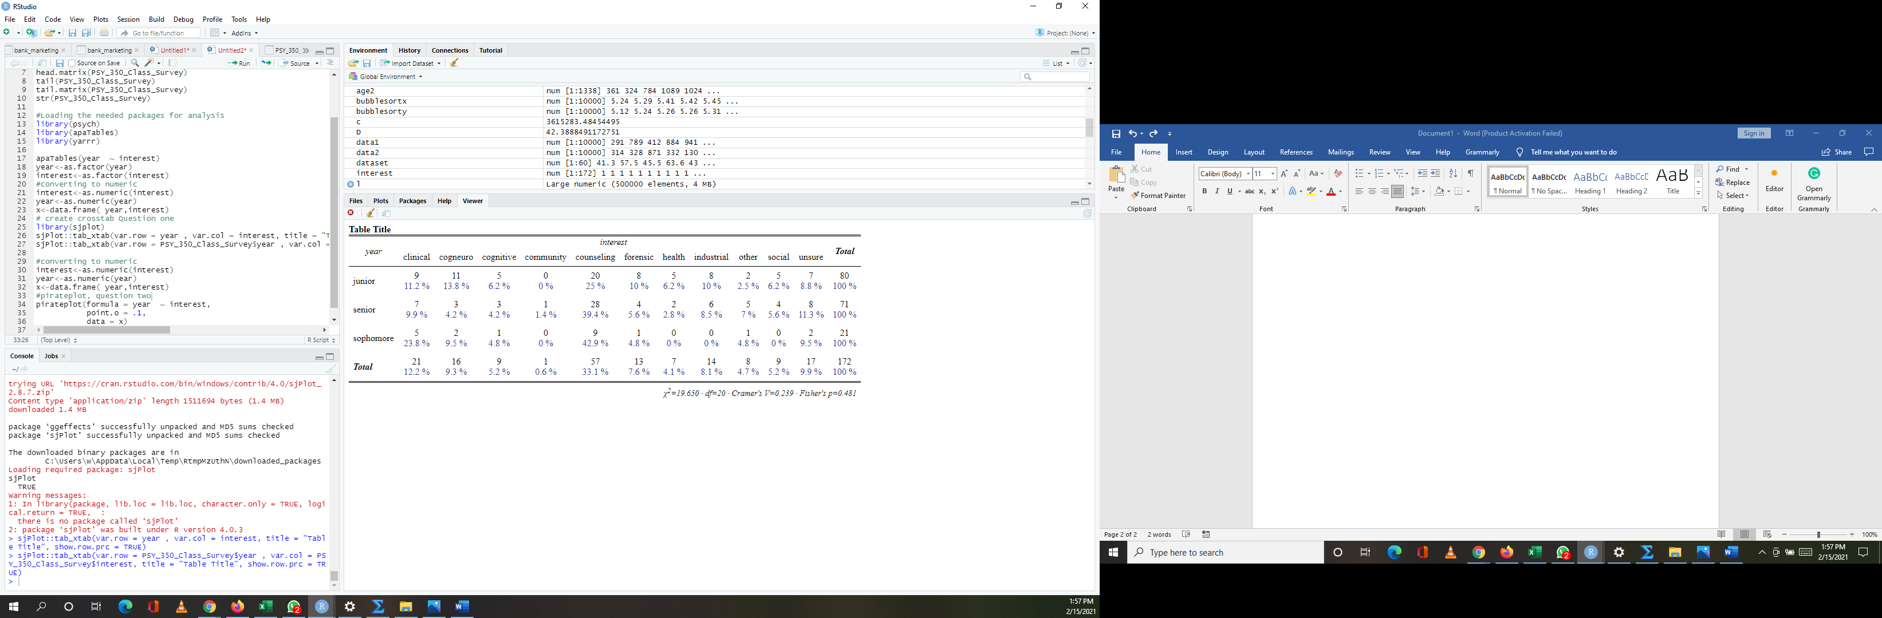
Junior studenst with proportion of 80/172.
Question two
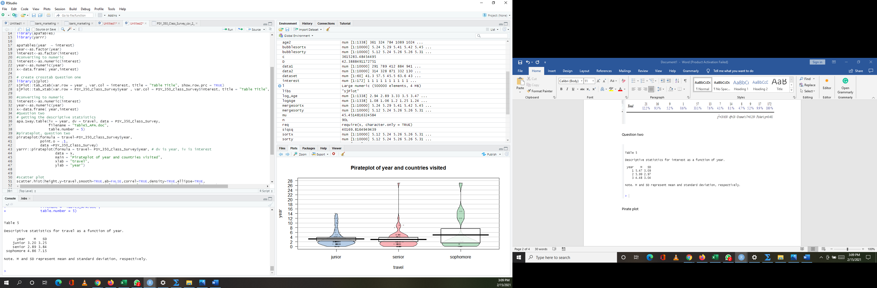

Pirate plot
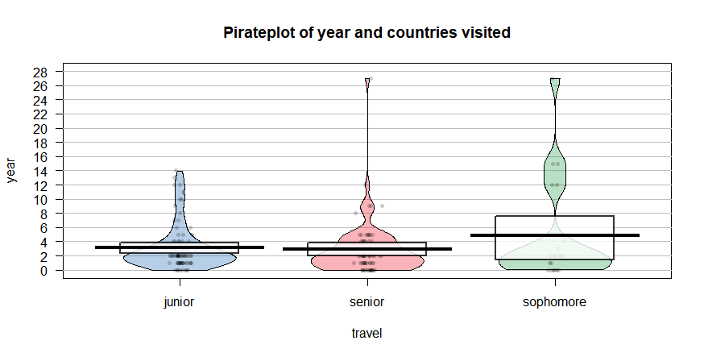

C
- Raw data,
The graph above pictorially describes the raw data which cannot be seen using the mean above, that is, we can see the extreme values and how the data points( travel) are distributed across the year
- Descriptive statistics,
The graph gives detailed information about mean, median and mode, and interquartile range as shown by the rectangular figures, the dark lines shows the means, while the upper corner shows the 75% quartile while the lower corner shows the 25% quartile.

Question three
Yes, from the graph below, we can see a linear positive relationship hence we conclude that they are positively related.
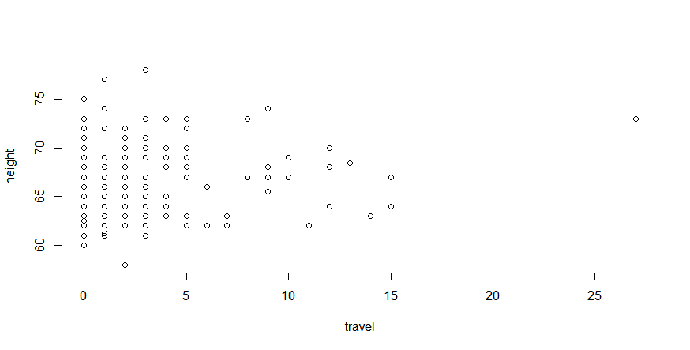

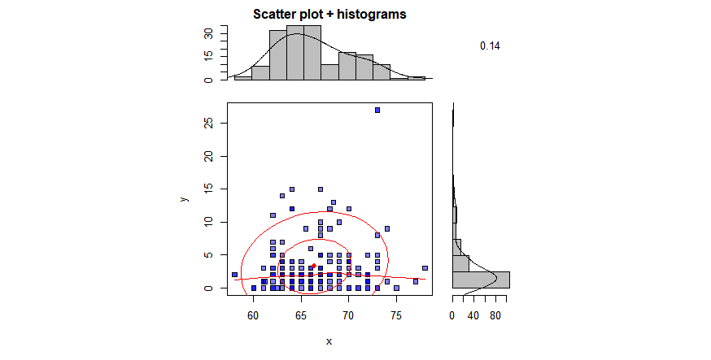
b. Correlations
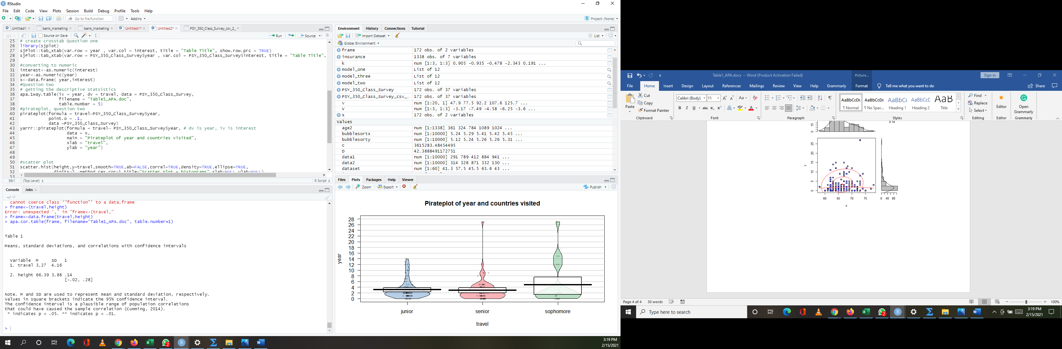

c. Yes, I used na.omit() function to omit any missing data points.
Question 4
a).
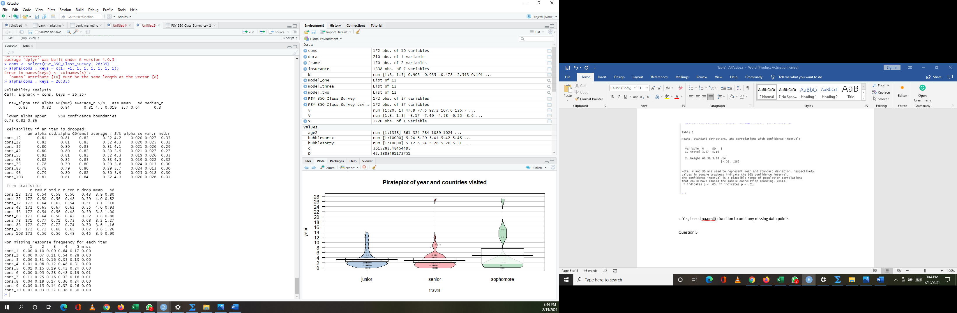
The internal consistency reliability for the cons scale is 0.82.
b).Yes, since it is greater than 0.7.
raw_alpha: Cronbach’s α (values ≥ .7 or .8 indicate good reliability; Kline (1999))
Question five
a.
vars n mean sd median trimmed mad min max range skew kurtosis se
X1 1 172 3.68 0.64 3.7 3.69 0.74 2.1 5 2.9 -0.11 -0.58 0.05
From the table above the mean level of overall cons is 3.68
b.

Table 2

Means, standard deviations, and correlations with confidence intervals

Variable | M | SD | 1 | 2 | 3 | 4 | 5 | 6 | 7 | 8 | 9 | 10 | 11
1. cons_1 | 3.89 | 0.80
2. cons_2 | 4.03 | 0.82 | .38**
 |  |  | [.24, .50]
3. cons_3 | 3.15 | 1.19 | .28** | .22**
 |  |  | [.14, .41] | [.07, .36]
4. cons_4 | 3.99 | 0.93 | .33** | .39** | .34**
 |  |  | [.18, .45] | [.25, .51] | [.20, .46]
5. cons_5 | 3.76 | 1.00 | .30** | .30** | .30** | .36**
 |  |  | [.16, .43] | [.16, .43] | [.15, .43] | [.22, .48]
6. cons_6 | 3.80 | 0.80 | .28** | .42** | .14 | .37** | .41**
 |  |  | [.13, .41] | [.29, .54] | [-.01, .29] | [.23, .49] | [.28, .53]
7. cons_7 | 3.19 | 1.28 | .27** | .15* | .43** | .41** | .22** | .07
 |  |  | [.12, .40] | [.00, .30] | [.30, .54] | [.28, .53] | [.08, .36] | [-.08, .22]
8. cons_8 | 3.56 | 1.17 | .23** | .17* | .43** | .38** | .26** | .11 | .83**
 |  |  | [.08, .37] | [.02, .31] | [.30, .55] | [.25, .51] | [.11, .39] | [-.04, .25] | [.78, .87]
9. cons_9 | 3.57 | 1.27 | .27** | .23** | .35** | .35** | .15 | .11 | .66** | .68**
 |  |  | [.12, .40] | [.09, .37] | [.22, .48] | [.21, .47] | [-.00, .29] | [-.04, .26] | [.57, .74] | [.59, .75]
10. cons_10 | 3.94 | 0.90 | .25** | .19* | .32** | .22** | .14 | .19* | .35** | .41** | .39**
 |  |  | [.11, .39] | [.04, .33] | [.18, .45] | [.08, .36] | [-.01, .28] | [.04, .33] | [.21, .48] | [.27, .52] | [.25, .51]
11. neatness | 3.04 | 1.28 | .30** | .09 | .34** | .31** | .17* | .06 | .52** | .49** | .48** | .26**
 |  |  | [.15, .43] | [-.06, .24] | [.20, .47] | [.17, .44] | [.02, .31] | [-.09, .21] | [.40, .62] | [.36, .59] | [.35, .59] | [.12, .40]
12. travel | 3.29 | 4.18 | -.14 | -.12 | -.13 | -.08 | -.00 | -.11 | -.16* | -.18* | -.18* | -.09 | -.05
 |  |  | [-.28, .01] | [-.26, .04] | [-.28, .02] | [-.23, .07] | [-.15, .15] | [-.25, .04] | [-.30, -.01] | [-.32, -.03] | [-.33, -.03] | [-.23, .07] | [-.20, .10]

Note. M and SD are used to represent mean and standard deviation, respectively. Values in square brackets indicate the 95% confidence interval for each correlation. The confidence interval is a plausible range of population correlations that could have caused the sample correlation (Cumming, 2014). * indicates p < .05. ** indicates p < .01.

C
Scatterplot for all the correlations
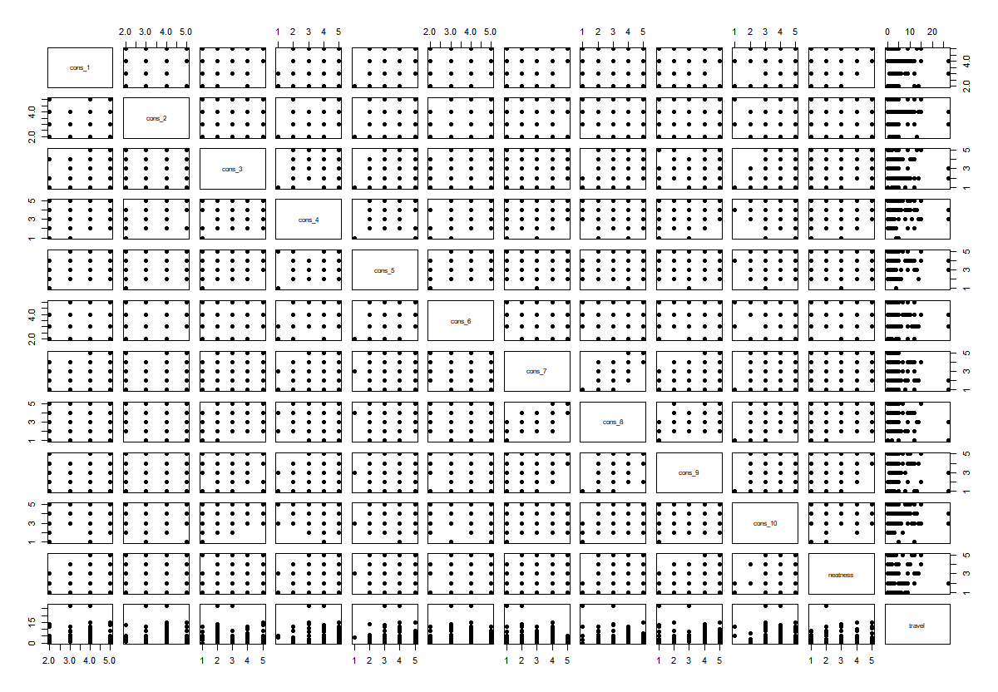

The needed screenshot

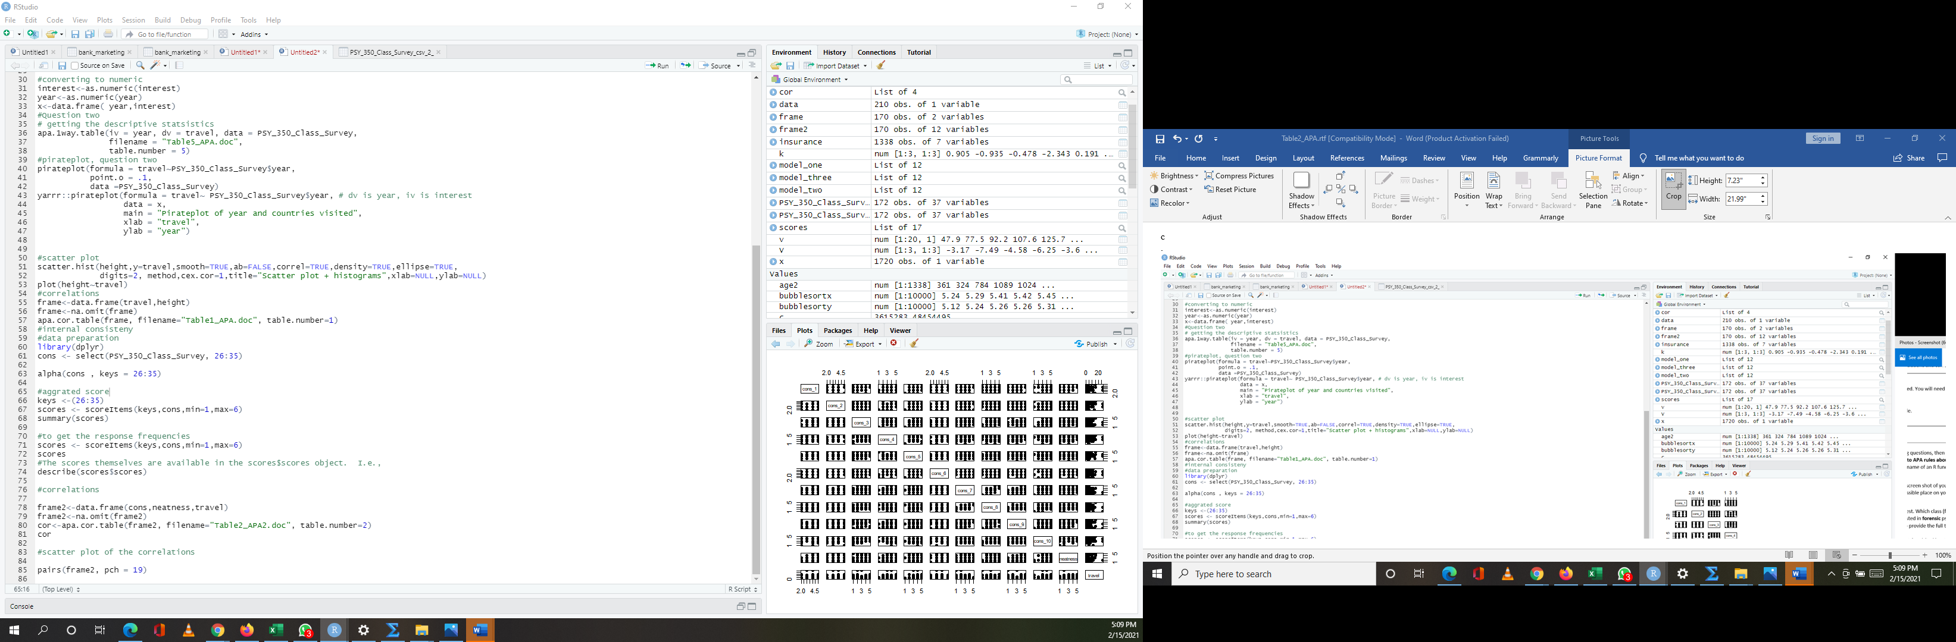
.

References
Kline, P. (1999). The handbook of psychological testing (2nd ed.). London: Routledge.

